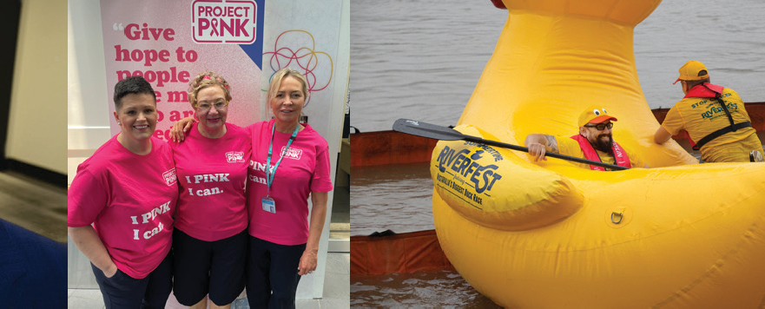
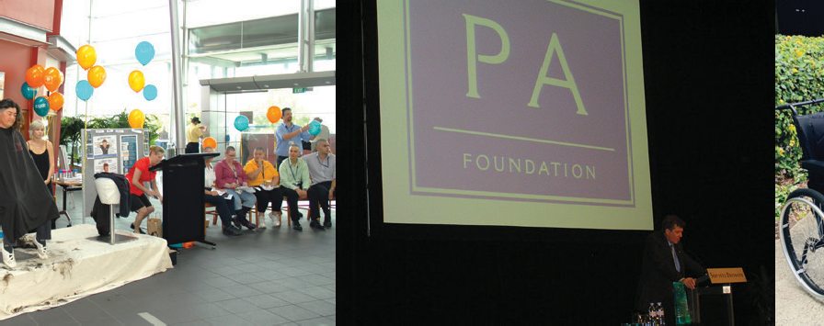





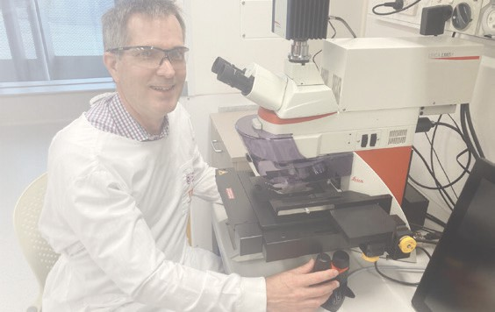
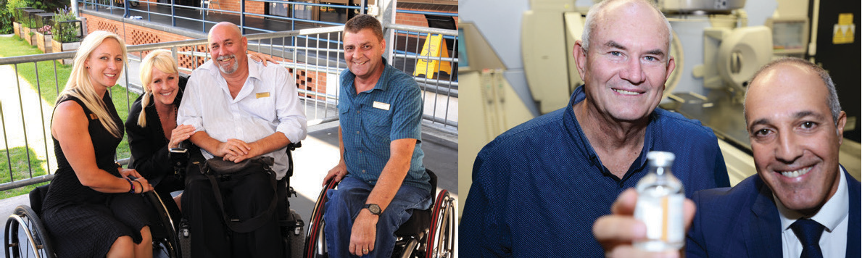


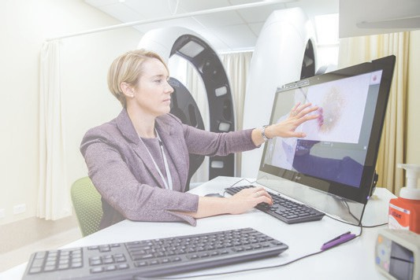



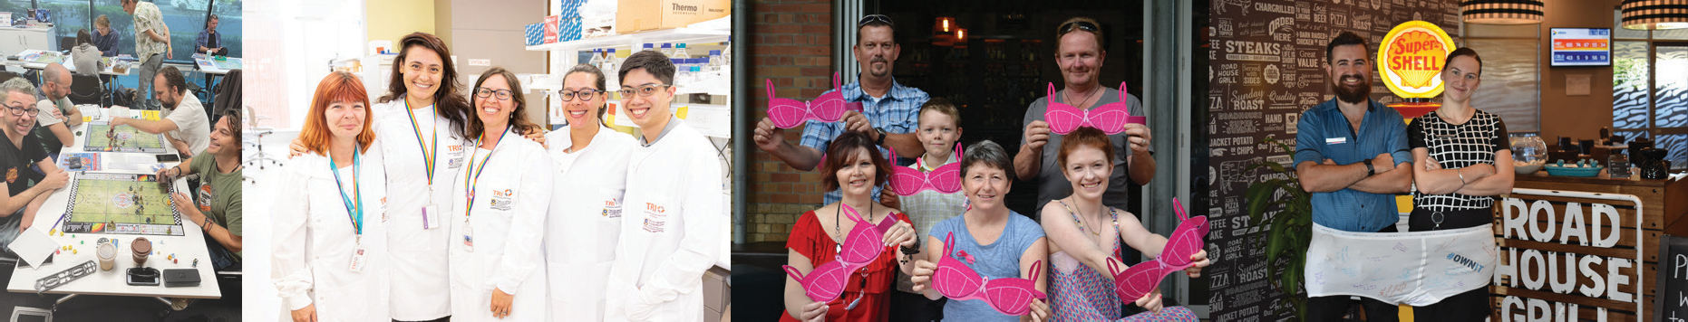


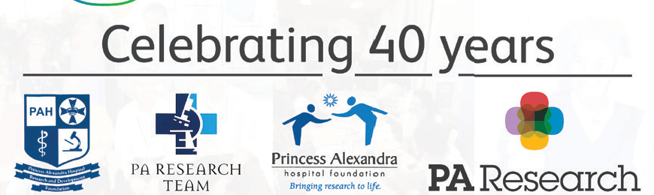

Opportunities:
Celebrate 40th milestone with rebranding and expansion; strengthen connections with MSH patients and leverage Hospital Funds.
Target growing communities around MSH hospitals, building relationships and support.

Enhance fund generation, spending, and cultivate innovative partnerships and campaigns.

Collaborate with executives, nurture relationships, and capitalize on tech- savvy community with patient-centric branding.
Your place to give.
We are pleased to present the Foundation’s FY24-FY28 Strategic Plan. Celebrating our 40th anniversary, this journey has been transformative. It has provided us with the opportunity to reﬂect on our core values, celebrate our spirit, and envision a broader, and increasingly impactful future.
Our priorities not only reﬂect our aspirations but also articulate our vision for the Foundation we aim to become. The unwavering dedication of our staff, donors, partners, and volunteers to being a values-driven organisation has made an extraordinary impact on the health and well-being of our patients and their families.

We take immense pride in being the philanthropic partner of the Metro South Hospital and Health Service
(MSH). Over time, our goals will transform into milestones in our history that we can all reﬂect upon with pride. As we embark on this new phase, our courage, belief in our vision, and commitment to partnerships underscore our dedication to operating as part of a collective team deeply invested in philanthropy for the health and well-being of our community and people.
Together we are bringing the highest quality healthcare to Southeast Queensland and the communities we serve. We do this through nurturing relationships and enrich lives through the act of giving while remaining focused on our patients and community. Funds raised go toward world leading research, hospital facilities and equipment.
Our core values :
Strategic Plan 2024-2028
Vision
Improve the health and well-being of Queenslanders as the healthcare charity of choice, supporting world-leading health research, equipment, and education.
We’re the Foundation known for delivering outcomes that enhance health services and trust.
We collaborate with donors, partners, researchers, and MSH to advance the health of our communities.
We prioritise funding for impactful research, equipment, practical initiatives supporting patients and staff, and education to improve healthcare outcomes.
We safely and ethically manage donor and partner funds, ensuring a high return on investment and embedding sustainability in all our actions.
Purpose
To nurture relationships that enrich lives through giving, in an impactful, responsible, and ethical way to deliver research, equipment, and education for better healthcare outcomes.
We work with and for our community, communicating and celebrating the impact of Foundation initiatives to our stakeholders.
Risks:
Confusion from rebranding and managing multiple sites; increased staff to
connect with and lack of researcher support.

Loss of clarity about mission during expansion; loss of momentum from hospital leadership changes and alignment issues with MSH strategy.

Inability to meet funding commitments and adapt to changes in charity regulations.

Community

Ethics

Impact

Leadership

Trust


Our Impact

Be a catalyst for change through clinically led research funding, education, and equipment.

We provide access to funding for research from early career researchers to research excellence that improves healthcare outcomes.
Our team provides infrastructure to support educational activities and events with impact.
We fund innovative equipment that transforms health care and report their impact now and into the future

Our reporting and monitoring detail impact of early researcher’s work addressing health and clinical challenges.

The benefits of educational activities and events are documented and reported.

The benefits from the investment of innovative equipment is documented and promoted, furthering the reputation of MSH and the Foundation.

Our impact is communicated to donors, partners and the community growing the success of our fundraising programs and leading to new donor relationships

We develop the skills to embrace and drive research, innovation, improvement, and translation.

People, Purpose, and Pathways
Outcomes and Impact
Objectives
Strategies
What does success look like?
Supporting MSH Strategy
Objectives
Strategies
What does success look like?
Supporting MSH Strategy
Donors, Partnership and Pathways

Provide our donors and partners with clear pathways to give.

In partnership with MSHHS we will increase patient and staff engagement by making our brands
visible and trusted places to give for impact.
Our team will commit to continual improvement as leaders in engaged philanthropy.
Together we will develop new and innovative campaigns and partnerships to increase giving.

Together we will achieve 25% of patients consenting to being contacted by 2026.
We will increase total number of gifts received, campaigns conducted and the duration of donor relationships.
Patients, staff, donors, and partners recognise our brands as safe and effective places to give for
impact in their local community.
We lead the health sector in workplace giving.
Together with our partners and their employees we will develop industry leading partnerships.

We partner with consumers and prioritise their needs, and experiences.

Our Investment
Invest in clinically led research, equipment and education that improves health services and outcomes for our community.

We partner with the MSH research committee to attract, select, and support impactful research.
We invest in impactful research, equipment, education, and patient facilities in and for our community.
We invest our donor’s and partner’s funds safely, ethically and in compliance with financial standards whilst ensuring a high return on investment (ROI) and monitor expenditure to ensure project progress and completion.
Together we invest in early career clinical and First Peoples researchers by supporting capacity building and opportunity.

Our reporting and monitoring show improved health outcomes as a result of our investments in research, equipment and education
Our impact is communicated to donors, partners and community growing the success of our fundraising programs and leading to new donor relationships.

We develop the skills to embrace and drive research, innovation, improvement, and translation.

Our People and Culture
Foster a culture is of collaboration, respect, transparency, and continuous learning.

We partner with MSH and to deliver the best health and well-being outcomes through the: • PA Foundation
- Logan Hospital Fund
- Redland Hospital Fund
- QEII Hospital Fund
- Beaudesert Hospital Fund
We embrace and represent diversity and inclusion; respect for First Peoples to reflect the diversity of culture and community we serve.
We integrate sustainability in everything we do.
We invest in growing our reach and impact through our team and new technologies, that create opportunities for more funding to improve health outcomes for our community.

We engage, retain, grow, and invest in the best staff to deliver our Vision.
We are recognised by patients, staff, donors, and partners as the trusted and effective place to give with measurable impact.
We ensure that every communication and campaigns represent our diverse community and support better experiences and outcomes for Australia’s First Peoples.
We meet diversity, inclusion, and sustainability goals.

We understand and meet the diverse needs of all people in our community.

